# CS 255 System Design Document Template

Arica Bryant

## UML Diagrams

### UML Use Case Diagram

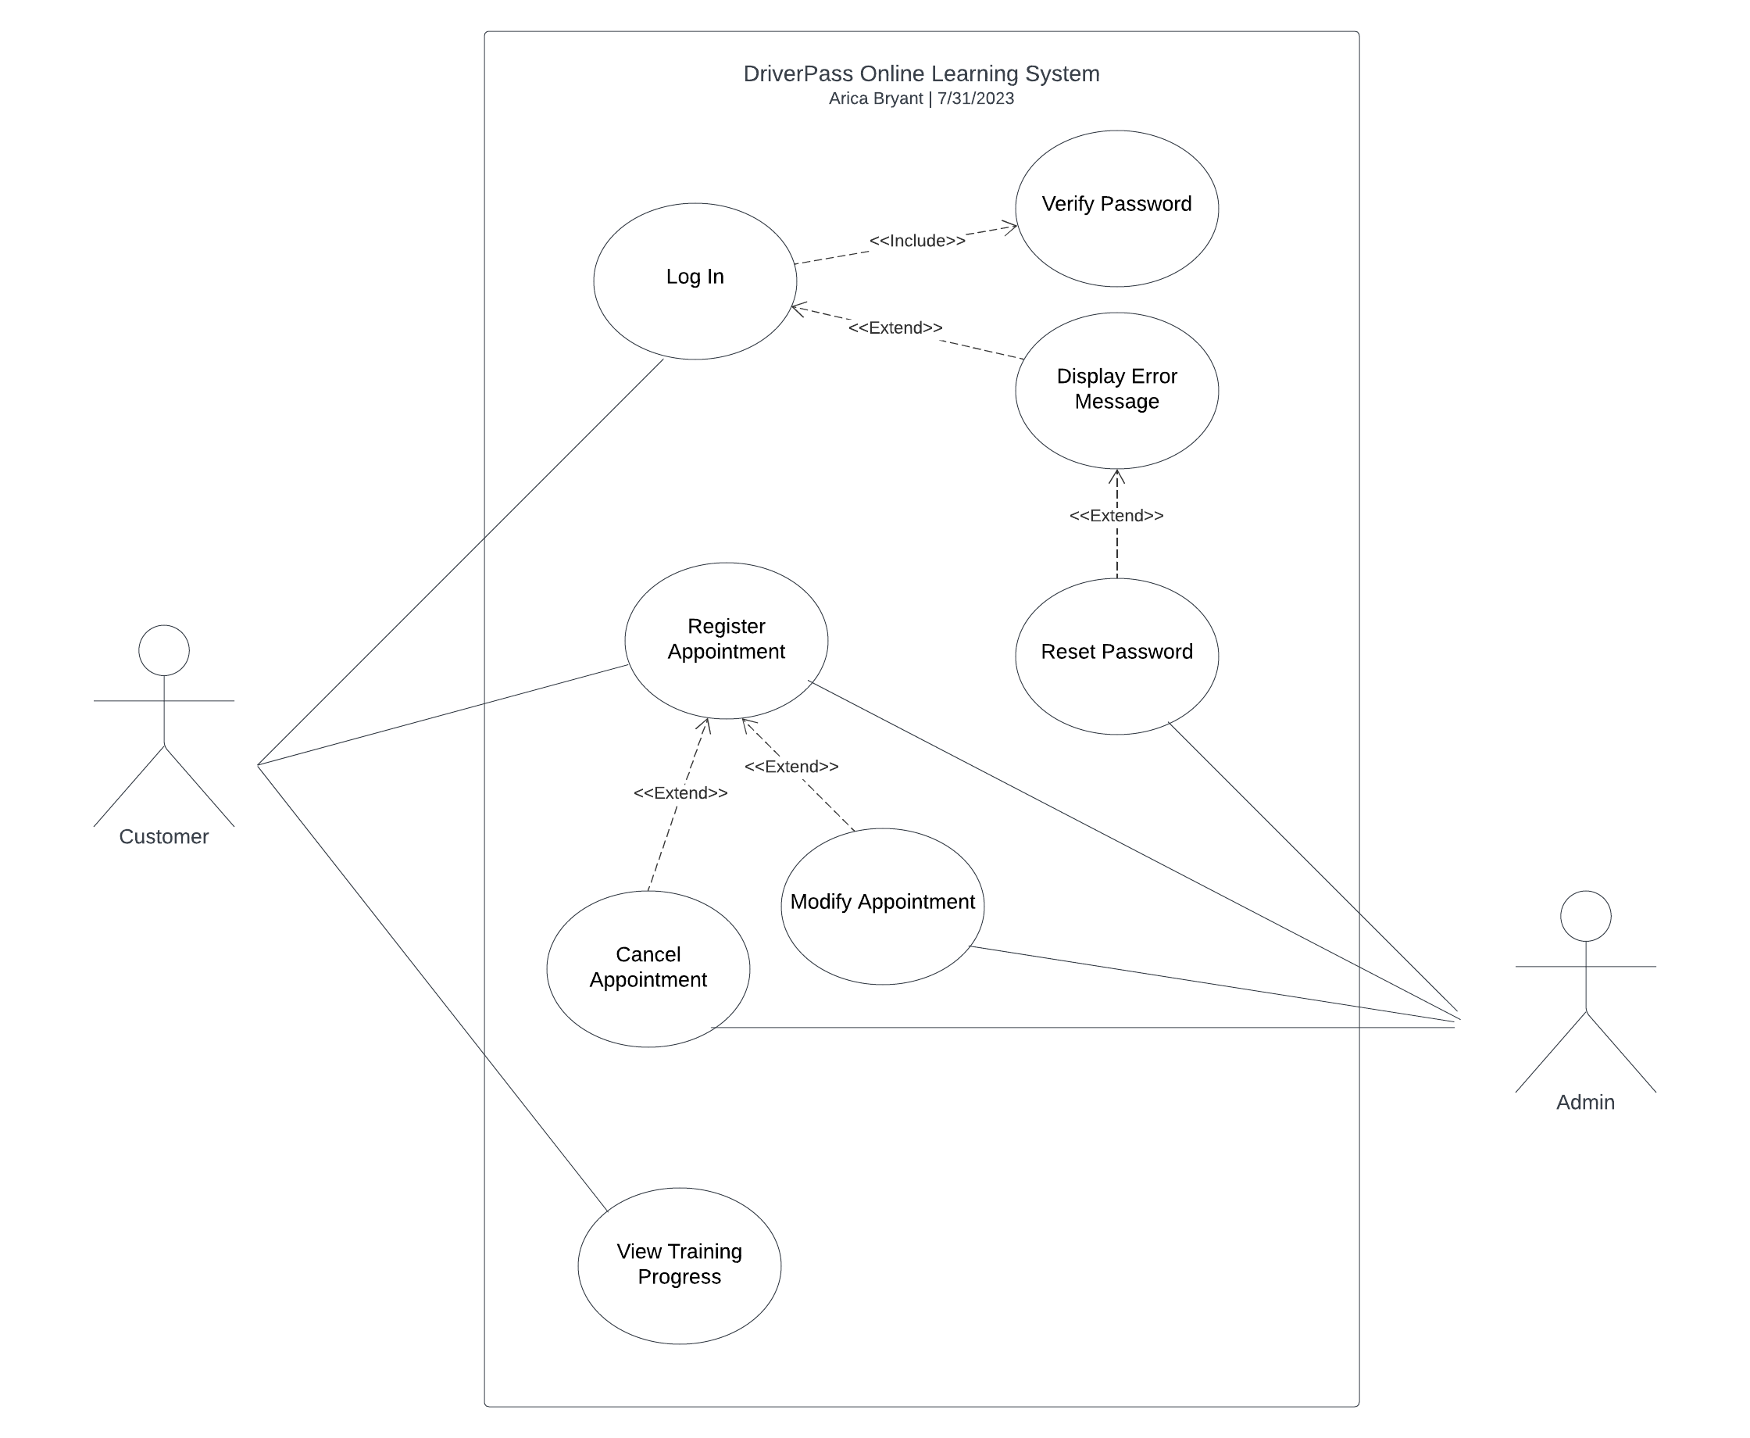

### UML Activity Diagrams

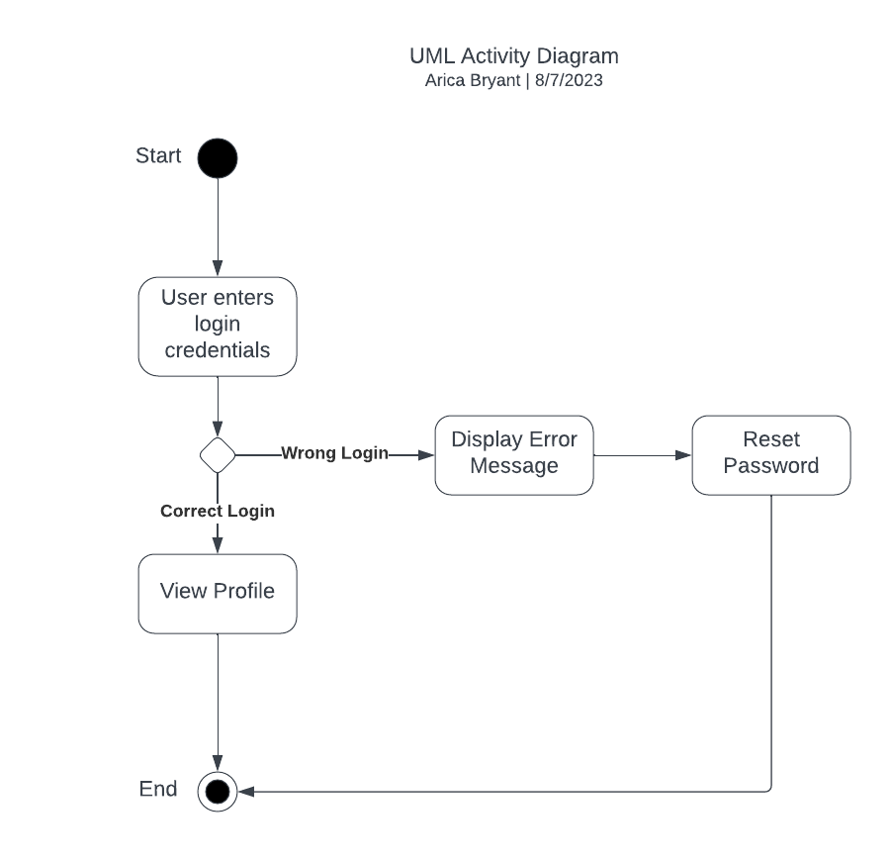

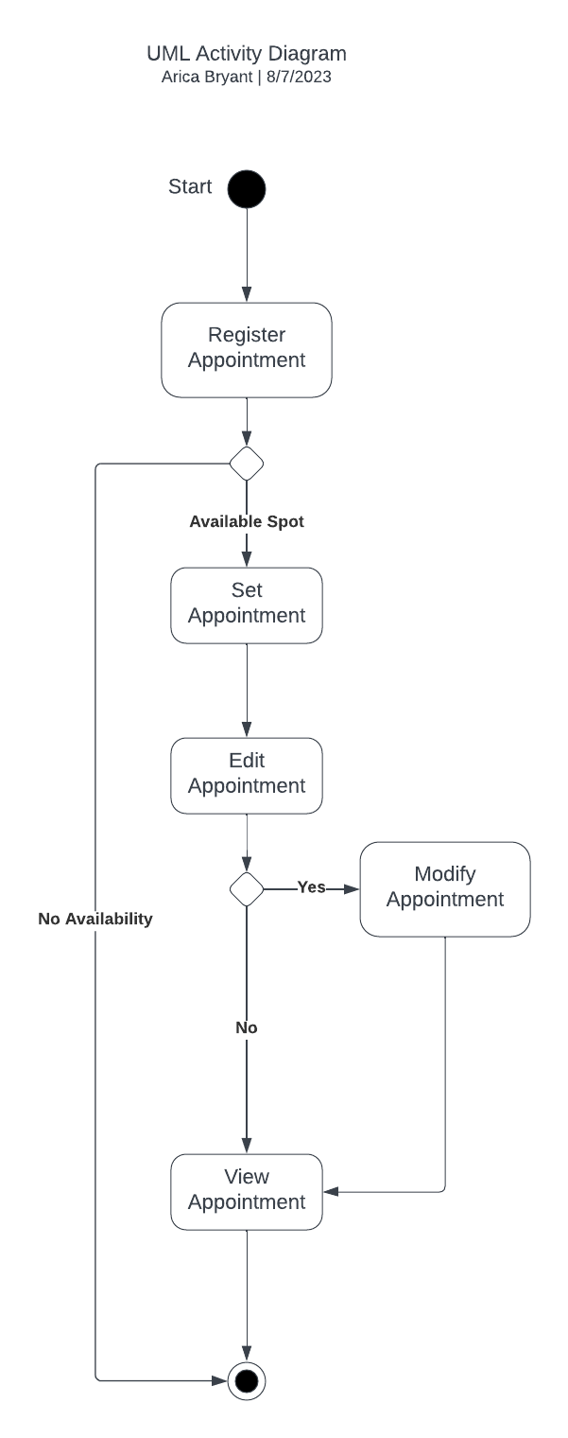

### UML Sequence Diagram

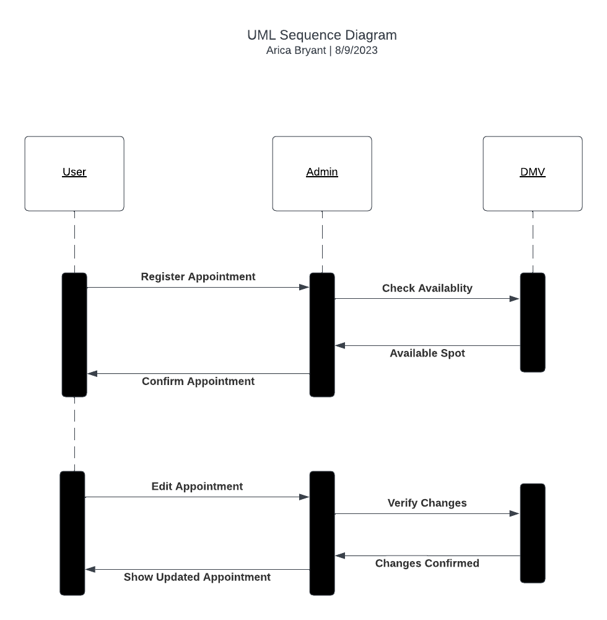

### UML Class Diagram

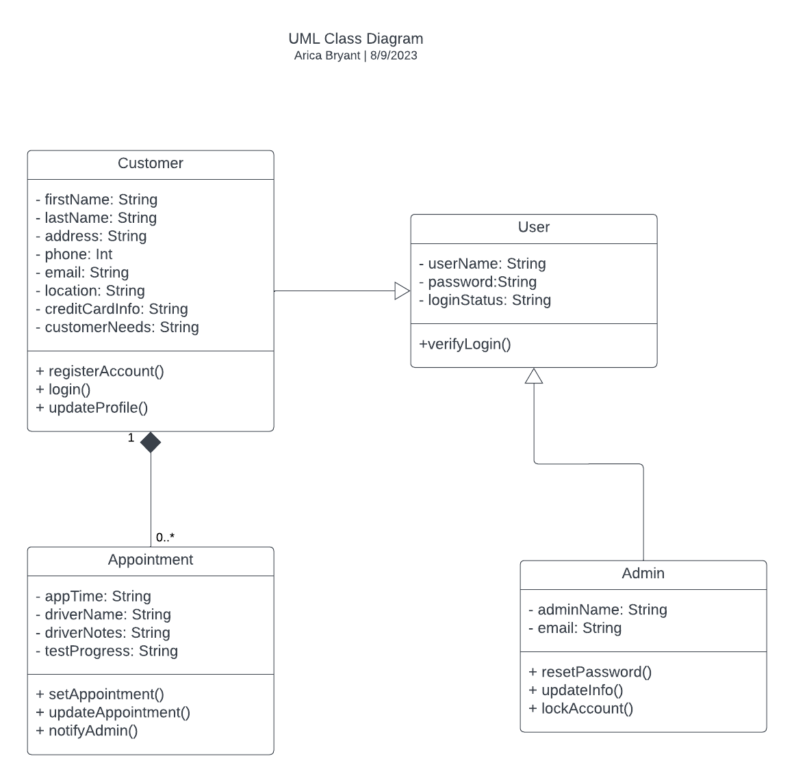

## Technical Requirements

Based on these diagrams, there are some technical requirements that would be needed to ensure the system will function smoothly. First, there needs to be a way for the administrator to update the online tests and certifications based on changes to DMV rules as they occur. Second, there needs to be security software for the Administrator to monitor account activity and lock an account if suspicious activity is detected.